Abstract— In order to accurately analyze the relationship between variables affecting solar power, this paper propose mediation models using crisp and fuzzy data.
Mediation and Fuzzy Mediation Analysis for Multiple Covariates and Its Applications to Solar Power Data

Introduction
As interest in renewable energy grows, many studies have been conducted to predict solar power. Unfortunately, there have been few papers taking into account the ambiguity of solar power generation. Since it is important to accurately understand the relationship between variables before prediction, this paper propose four models. Two of them are mediation models for multiple covariates if there is one mediator or multiple mediators. The other two are similar to the previous two models but use fuzzy variables. By setting weather data as independent variables, solar radiation as a mediator, and solar power as a dependent variable, this paper analyzes whether solar radiation mediates meteorological conditions with solar power. Plus, this study contrasts the models using crisp and fuzzy data then brings out statistical inference of total, direct, indirect effect.

Methods and Results
Fuzzy Mediation Analysis with one mediator
When there are several independent variables, especially if those include vague information, a fuzzy mediation analysis model with one mediator can be proposed as follows:
,
where
Here, is the total effect of is the indirect effect on through and , and is the direct effect.
Easily checked, the following equation holds.
()

Fuzzy Mediation Analysis with multiple mediators
Moreover, if there are several mediators and all the variables are vaguely observed, then a fuzzy mediation analysis model with multiple mediators can be proposed as follows:
,
where and
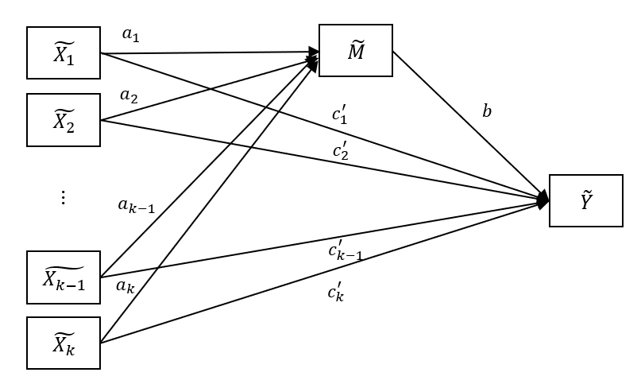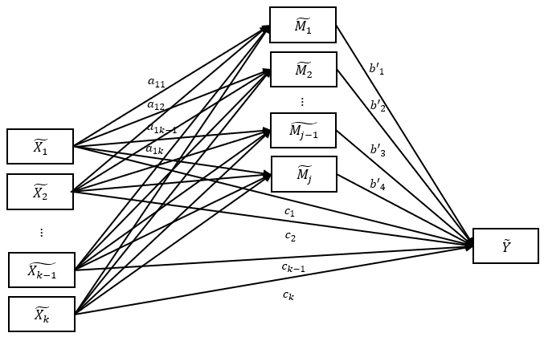
Figure 1. Fuzzy Mediation Analysis for Multiple Covariates with one mediator and multiple mediators
From the Table 1, the direct and indirect effect of the rain in weather information data does not significantly affect solar power in CMA(Crisp Mediation Analysis). On the other hand, in FMA(Fuzzy Mediation Analysis) they are significant.
Effect | Method | z(t) | p-value
Total | CMA | -4.348 | <0.001
 | FMA | -366.673 | <0.001
Direct | CMA | -1.394 | 0.1633
 | FMA | -895.365 | <0.001
Indirect | CMA | -0.898 | 0.369
 | FMA | 184.145 | <0.001
Table 1. Statistical inference about rain

Conclusion
Compared crisp and fuzzy mediation model, without considering the ambiguity of data, the overestimated or biased result could be derived. As a future study, model of this study will be broadened and used for mediation, moderation, mediation-moderation analysis.
Acknowledgment
This work was supported by the National Research Foundation of Korea(NRF) grant funded by the Korea government(MSIT) (No. 2020R1A2C1A01011131).
References
- J. H. Yoon, “Fuzzy Mediation Analysis,” Int J. Fuzzy Syst., vol. 22, no. 1, pp. 338-349, 2020.
- J. H. Yoon, “Fuzzy Moderation and Moderated-Mediation Analysis,” Int J. Fuzzy Syst., vol. 22. no. 1, pp. 338-349, 2020.
- J. H. Yoon, S. H. Choi, “Fuzzy Least Squares Estimation with New Fuzzy Operations,” Advances in Intelligent Systems and Computing, vol. 190, pp. 193-202, 2013.
- L.A. Zadeh, “Fuzzy sets,” Information and control, vol. 8, pp. 338-353, 1965.
- R. M. Baron, D.A. Kenny, “The moderator- mediator variable distinction in social psychological research: conceptual, strategic, and statistical considerations,” J Pers Soc Psychol, vol. 51, no. 6, pp. 1173-82, 1986.

 *This work was supported by the National Research Foundation of Korea(NRF) grant funded by the Korea government(MSIT) (No. 2020R1A2C1A01011131). Y.K. Lee is with the Dept. Mathematics and Statistics, Sejong University, Seoul, 05006, South Korea (e-mail: leeyeonkyung@naver.com) J.E. Lee is with the Dept. Mathematics and Statistics, Sejong University, Seoul, 05006, South Korea (e-mail: wheeboo@naver,com) J.H. Yoon is with the Dept. Mathematics and Statistics, Sejong University, Seoul, 05006, South Korea (e-mail: jin9135@naver.com)

